**Diverse lithic production strategies in southwest China during Late Middle Pleistocene**

**Authors:** Yue Hu1,2*, Ben Marwick3, Yamei Hou4,5, Weiwen Huang4,5, Bo Li2,6

**Affiliations:**

1 Department of Archaeology, School of History and Culture, Sichuan University, Chengdu 610207, China

2Centre for Archaeological Science, School of Earth and Environmental Sciences, University of Wollongong, Wollongong, NSW 2522, Australia

3Department of Anthropology, University of Washington, Seattle 98195, USA

4Key Laboratory of Vertebrate Evolution and Human Origins, Institute of Vertebrate Paleontology and Paleoanthropology, Chinese Academy of Sciences, Beijing 100044, China

5Institute of Vertebrate Paleontology and Paleoanthropology, Chinese Academy of Sciences, Beijing 100044, China

6ARC Centre of Excellence for Australian Biodiversity and Heritage, University of Wollongong, Wollongong, NSW 2522, Australia

*Correspondence to: YH (yh280@scu.edu.cn)

**Keywords:** Middle Palaeolithic, Southwest China, Guanyindong, Diversity, Levallois, Quina

# **Abstract**

It has long been considered that there were no obvious lithic technological changes in East Asia during the Middle and Late Pleistocene, and the lithic industries in this region were dominated by simple a core-flake production system until the Late Pleistocene when Upper Palaeolithic forms appeared. We challenge this view with evidence of multiple Middle Palaeolithic lithic production systems appearing much earlier, from the Guanyindong site, southwest China, dated to 170–80 ka. Our analysis of the lithic assemblage from this site reveals technological diversity in methods of core reduction and tool retouching. These methods include Levallois, discoid systems, core-on-flake, and volumetric methods, consistent and contemporary to those widely observed in west Eurasia. The presence of a “pool of technological knowledge” reflects a mosaic package of multiple technological or strategical capability acquired by Late Middle Pleistocene populations in Guanyindong during this period. This ability clearly differs with what we observed in Early Palaeolithic as well as the notion of a long-lasting static Middle Palaeolithic in East Asia.

# **Introduction**

The late Middle Pleistocene (LMP) witnessed the transition from Lower Palaeolithic to Middle Palaeolithic (MP) in west Eurasia and Africa (Early Stone age to Middle Stone Age) and in many areas included significant milestones in human evolution, such as the replacement of *Homo erectus* by *Homo sapiens* and other species (Hublin 2009, Hublin, Ben-Ncer et al. 2017, Jacobs, Li et al. 2019). This transition was accompanied by the emergence and wide spread of the Levallois concept in Africa, Europe and Levant (Tryon, McBrearty et al. 2005, Goren-Inbar 2011, Fontana, Moncel et al. 2013, Shimelmitz, Weinstein-Evron et al. 2016). This lithic technology is often recognised as the hallmark of the Middle Palaeolithic (McBrearty and Brooks 2000, Monnier 2006). However, Levallois lithic technology does not have a monopoly on technological innovation in the LMP. Less obvious shifts, but still documented and discussed abundantly, are an important part of the Middle Palaeolithic (MP) technological complex, in combination with the Levallois concept. This implicit shift, namely the various flake reduction systems and small tools made on flakes, replaces large cutting tools (LCTs) and core tools (Bar-Yosef 1999, Kuhn 2013), is almost as indictive as the Levallois concept in symbolizing MP technological change, particular in Europe.

Since the end of 19th century, the importance of MP flake-based industries started to be realized by pioneer European scholars such like de Mortillet, Commont, Breuil(Mortillet 1873, Commont 1908, Breuil and Koslowski 1932). Understanding of the MP developed through several stages. At the first half of last century, it was regarded as a homogenous period both geographically and chronologically (according to Delagnes and Meignen 2006). In 1950s, with the rise of typological approaches advocated by Bordes, the impression of MP homogeneity was altered by recognition of distinct Mousterian complexes (Bordes 1953, Bordes 1981) according to different proportions of retouched tool types. The underlying mechanisms that caused these differences have been investigated a source of considerable debate (Bordes 1950, Binford and Binford 1966 , Dibble 1987). Simultaneously, increasing attention has also been given to technological approaches, especially the concept of the chaîne opératoire (Leroi-Gourhan 1964, Leroi-Gourhan 1966, Tixier 1978, Tixier, Inizan et al. 1980). This technological approach, trying to understand the conceptual process that underlie the different stages of tool production and usage, probes the life history of a tool since acquisition of raw material, until the abandonment after usage (Eric Boëda 1990, Sellet 1993, Bar‐Yosef and Van Peer 2009). This approach allows archaeologists to examine lithic production in a systemic way, and has revealed a diversity of technical strategies of lithic production for the MP (see the reviews and examples in Delagnes and Meignen 2006).

The different production strategies include multiple variants of Levallois concepts (Boëda 1994, Boëda 1995), discoid production (Boëda 1993, Peresani 2003), laminar production (Boëda 1990), and the Quina method (Bourguignon 1996). These novel technological systems reflect changes among MP hominins which differ from their ancestors in, for example, cognitive, mobility strategies, social and adaptive behaviours (Boëda, Connan et al. 1996, Gamble 1999, Berna and Goldberg 2007, Soressi and d'Errico 2007, D'Errico 2008, Rots 2009, Cârciumaru, Ion et al. 2012, Goldberg, Dibble et al. 2012), demographic growth, and expansion of hunting territories (Shennan 2001, Kuhn 2013).

The proximal factors more closely linked to technological variability might include raw material constraints, different reduction intensity, the function of tools, the range of technical knowledge (Delagnes and Meignen 2006), population density, ecological settings, etc (Rolland and Dibble 1990). The interaction of these factors and the geographical factors that influence them may also have caused a discrepancy between East Asia and west Eurasia. For instance, the distinctiveness of a ‘Middle Palaeolithic’ in East Asia has been hotly debated since the mid-20th century (Movius 1948, Boriskovsky 1978, Gao 1999, Gao and Norton 2002, Norton Christopher and Jin Jennie 2009, Kei 2012). One of the central debates is about the presence of prepared-core techniques, including that known as the Levallois, a specific hierarchical core reduction strategy, involving multiple stages of shaping a mass of stone core in a predetermined way (Boëda 1995). Starting around MIS 11-8 (Kuhn 2013), and peaking in MIS 6 (McBrearty and Brooks 2000), Levallois strategies persisted in Africa and West Eurasia until they was gradually and mostly replaced by blade and microliths technologies, disappearing from many assemblages after MIS 3 (~50–30 ka) (Monnier 2006).

In contrast to west Eurasia and Africa, it has been argued that there was a lack of distinct technological change (i.e., presence of the Levallois concept) in lithic technologies in east Asia since the Lower Palaeolithic period (Gao 1999) until relatively late in Upper Palaeolithic period, approximately 30 to 40 ka, which may be due to modern humans migrating into these regions, bringing the new technologies with them (Foley and Lahr 2003, Bae, Douka et al. 2017). The lack of complex stone tool technologies in East Asia before MIS 3 implies that hominin populations in this region may have been culturally and genetically isolated during the early and middle Pleistocene (Wang 2017). This theory, however, was challenged by a recent discovery of Levallois technology from the Guanyindong site, southwest China, dated to ~170 to 80 ka (Hu, Marwick et al. 2019). The findings from Guanyindong suggest that the degree of stasis and isolation in the stone artefact technologies in East Asia during Middle and Late Pleistocene may have been overestimated. We present here the results of a systematic study of the lithic assemblage from Guanyindong, which further reveals diverse lithic production strategies that are comparable and to those found in west Eurasia and Africa during the same period.

Detailed description of the geological context and stratigraphy of Guanyindong has been provided in Li et al. (1986) and Hu et al. (2019). The artefact-bearing sediments from the west entrance were dated to between ~170 and ~80 ka (Hu, Marwick et al. 2019). To study the lithic characteristics of the Guanyindong assemblage, here we report on our analysis of a total of 2,211 artifacts from the west entrance (**see Supplementary Information Table S1**). Our sorting procedure divided the collection into four preliminary categories according to a technological approach, described further below. The categories consist of cores (n=248), flakes and flake fragments (n=195), retouched pieces (n=999), debris and chunks (n=769). Extensive technological analysis of the entire assemblage is described in **Supplementary Information (SI)**. The underlying phases were identified from the production processes of cores, flakes and retouched pieces, and suggest a complicated reduction system, including Levallois strategies, multiple blank production systems such as discoid, Quina, core-on-flake and volumetric cores.

# **Results**

## Levallois production

A detailed system of Levallois lithic technology was discussed previously (Hu, Marwick et al. 2019). In this paper, we explore the ‘standardization’ of Levallois flake in the assemblage by comparing main attributes between Levallois flakes and non-Levallois flakes. It has been suggested that Levallois debitage systems are optimal in terms of raw material economics and flake utility since they increase the raw material’s efficiency and the length of ‘cutting edge’ that can be created from a given blank (Brantingham and Kuhn 2001, Lycett and Eren 2013). In other words, Levallois flakes exhibit a greater standardization in their attributes compared with the ‘non-preferred’ flakes. In order to test this, we compared the coefficient of variation (CV) of Levallois and complete flakes (including retouched complete flakes) on the base of several essential attributes (**Table 1**). We found that the CV values of Levallois flakes are substantially smaller than those of complete flakes (Mann-Whitney W = 61; p = 0.033), supporting the prediction that Levallois flakes are more standardised than other complete flakes (Lycett and Eren 2013).  **Figure 1A-C** shows the dimension comparison between Levallois and non- Levallois flakes. Mass and metric dimensions are similar between Levallois and non-Levallois, but Levallois flakes are thinner than non-Levallois flakes. We might infer that the Levallois strategy was employed to reliably produce thinner flakes. Although the result of the comparison shows that Levallois flakes are statistically distinctive, whether they were ‘preferable’ needs to be tested through more systematic studies including refitting (unfortunately not possible in this site) and experimental analysis.

**Table 1 | Results of descriptive statistics for Levallois and non-Levallois flakes. ‘PLF’ stands for preferential Levallois flake; ‘CF’ stands for complete flake.**

|  | **Mean (mm)** | | **SD** | | **CV (%)** | | |
| --- | --- | --- | --- | --- | --- | --- | --- |
| PLF | CF | PLF | CF | PLF | CF | Difference |
| Length | 47.43 | 49.12 | 18.42 | 19.93 | 38.83 | 40.57 | -1.74 |
| Max dimension | 55.96 | 62.73 | 20.25 | 24.47 | 36.18 | 39.00 | -2.82 |
| Oriented width | 46.90 | 50.29 | 17.91 | 21.02 | 38.18 | 41.79 | -3.61 |
| Width at 25% max | 32.40 | 36.06 | 12.40 | 14.59 | 38.27 | 40.47 | -2.20 |
| Width at 50% max | 37.13 | 41.66 | 13.37 | 16.74 | 35.99 | 40.18 | -4.18 |
| Width at 75% max | 30.60 | 34.96 | 12.49 | 15.88 | 40.82 | 45.42 | -4.60 |
| Oriented thickness | 12.16 | 17.88 | 4.45 | 9.02 | 36.64 | 50.46 | -13.82 |
| Thickness at 25% max | 11.05 | 16.10 | 4.44 | 8.14 | 40.20 | 50.55 | -10.35 |
| Thickness at 50% max | 11.95 | 17.07 | 4.78 | 8.68 | 40.01 | 50.87 | -10.86 |
| Thickness at 75% max | 10.04 | 14.24 | 4.29 | 7.68 | 42.74 | 53.93 | -11.19 |
| Platform width | 31.69 | 33.46 | 16.38 | 18.28 | 51.68 | 54.64 | -2.95 |
| Platform thickness | 10.98 | 13.30 | 4.66 | 8.07 | 42.46 | 60.67 | -18.21 |

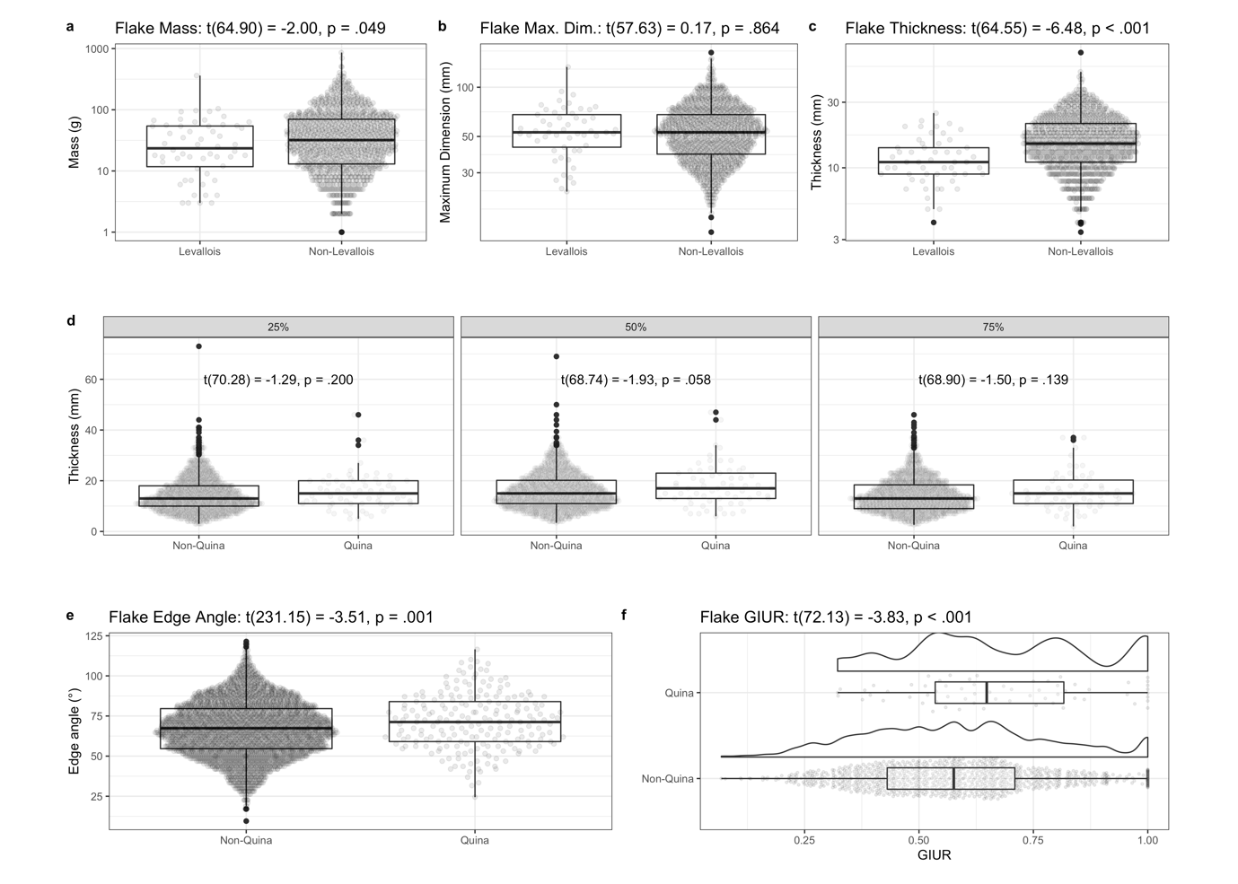

**Figure 1 | Comparison of Levallois flakes vs non-Levallois flakes and Quina tools vs non-Quina tools.** (A – C) Histograms showing comparison between Levallois flakes and non-Levallois flakes on mass, maximum dimension and thickness at 50% of maximum dimension. (D) Histograms showing comparison of thickness distributions between Quina and non-Quina tools at different locations on the flake (25%, 50% and 75% at maximum dimension). (E) Histogram of edge angles between Quina and non-Quina tools. (F) Histograms of GIUR of Quina and non-Quina tools, also showing a density line to reveal the details of the distribution of GIUR values.

## Discoid Production

Discoid/Mousterian debitage (Bordes 1961, Boëda 1993) has been found in many sites and shows significant variability (Jaubert 1993, Peresani 1998, Pasty 2000). For a discoid system, the core consists of two highly convex surfaces and these surfaces can be used for both flake detachment or as striking platforms within a single operational sequence. This can be contrasted with the Levallois strategy where the two surfaces are hierarchically related and cannot be reversed and their roles cannot be exchanged. The use of the discoid method in Guanyindong is indicated by ten discoid cores (see examples in **Figure 2a-c**) and diversified products such as triangles, and short thick flakes as well as debordants and backed flakes (see examples in **Figure 2** and **SI Figure S4**).

Most cores exhibit one flaking surface with peripheral exploitations by secant and steeped removals. Those cores bearing a pyramidal cross-section always have one surface remaining flat as striking platform and the other surface working as flaking surface formed by centripetal scars which extend to the distal end. The morphologies varied depending on the original blank shapes, either a sizable flake or a nodule.

The raw materials are dominated by chert (>90%). The median dimension of cores is around 70 mm and the average mass is about 160g. According to the major scars left on the working surface, those cores yield a limited number of products (always around 4-6). More than half of them have partial cortex (the cortex covers mostly 10%, but 50% area on some extreme specimen) remaining on the platforms or distal places, probably as a result of local or early stage of manufacture. Platforms are mostly plain.

A variety of end-products of discoid production are found in the Guanyindong assemblage including pseudo-Levallois points, short debordant flakes, triangular (Peresani 1998) and quadrangular flakes (see examples in **Figure 2e-g**). Among those products, Pseudo-Levallois points and debordant flakes appeared in a small quantity. Because both centripetal recurrent Levallois methods and discoid production can be responsible for these kinds of flakes, it is hard to separate those byproducts from either of the two production systems. The potency of debitage from discoid production is evidenced by a large number of flakes with triangular section (39% based on the data of complete unretouched flakes, although this section can be obtained by Quina system too) and numerous triangular flakes. Among the triangular flakes, many of them have a triangular scar covering most of the dorsal surface and creating the ridge that guided the detachment of the subsequent flake leading to the parallel or sub-parallel formation of ventral and dorsal surfaces and flat morphology. And most of those flakes were then retouched into tools (see **SI** for more details).

The relatively small number of discoid cores and large number of flakes potentially from discoid cores, as well as the high ratio of those transformed into tools may indicate a highly mobile subsistence strategy. The relative absence of late stage cores may due to transportation after the production of the targeted end-products which are short, thick and probably, in some way, pointed (i.e. triangular flakes). Despite the fact that the manufacture of Discoid methods needs a low degree of predetermination, the relatively high productivity (since it does not need re-preparation between each reduction phase) and technological investment required (Delpiano and Peresani 2017) reflects the anticipation capacity of knappers when evaluating the possible output and likely cost.

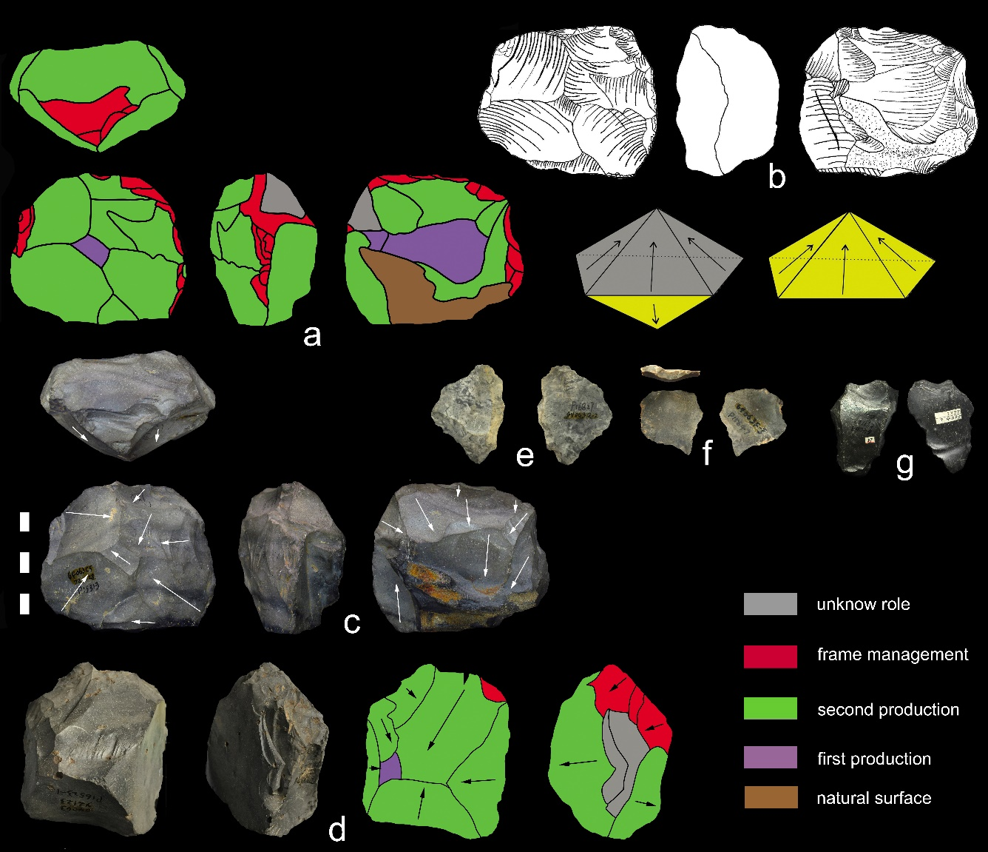

**Figure 2 | Discoid cores.** (a-c): scheme, sketch and photo of a discoid core, the white arrows show the directions of removals. The core is formed by two surfaces, with radioactive recurrent scars from two production phases left on each surface (one surface is complete peripheral exploitation and the other is partial peripheral exploitation). (d): photo and scheme of another discoid core. The black arrows show the directions of the removals. This core is mainly exploited on one side. (e-f): pseudo Levallois point. (g): triangle flake with a main triangular scar covers the dorsal surface.

## Quina exploitation

Quina exploitation at Guanyindong is directly evidenced on some Quina sidescrapers and Quina resharpening flakes (n=70, see example from **Figure 3a-e**); The retouching scars on these tools form a distinctive stepped morphology, especially where those scars overlapped on the retouched edge (cf. Agam and Zupancich 2020). The stepped cutting edge is related to either the amount of retouch it had received or the rejuvenation of cutting edges after extensive use. This kind of tool was probably produced to meet multiple functional requirements such like treating various organic materials including both animal (hides, meat) and plants (wood) (Hardy 2004, Hiscock, Turq et al. 2009). For example, by blunting the edge, knappers made the edges less efficient when processing hides (Preysler 2010). Frequent resharpening and recycling to extend the use-life of tools are probably another explanation (Dibble 1984, Lenoir 1986, Dibble 1987) and are typical principles of the Quina system (Delagnes and Rendu 2011).

Other observations from the assemblage that make the Quina exploitation identifiable mainly come from other 3 indirect evidence:

1. the prevail steep edges, the median retouched edge angle of the assemblage is nearly 70° (**Figure 1D-F**, also see discussion in **SI**);
2. relative thick blanks that provide high retouch potential (the average ratio of oriented width to oriented thickness = 3.1 (sd=1.06), and the mean thickness = 17.9mm (sd=8.69), see example in **Figure 3f**); and
3. several retouching phases (see discussion in **SI**).

Although there are debates about whether Quina retouch was deliberately produced (e.g. Lenoir 1986) or whether it was the result of resharpening thick blanks unintentionally (e.g. Dibble 1987), nevertheless, the clear, though relatively rare, presence of Quina artefacts at Guanyindong, indicates intensive retouching activity on long-lived tools, which is relevant to understanding mobility patterns of the hominin occupants of the site. In Europe, Quina products were frequently found with seasonally migrating fauna (Delagnes and Rendu 2011). This association, together with several successive retouching phases on the same edge, is often interpreted as indicating a higher level of mobility (Delagnes and Rendu 2011), which probably suggest frequent long distance travel . Making suitable economic responses to the environment reflects the adaptive capacity and plasticity of the hominins active in this region during Late Middle Palaeolithic.

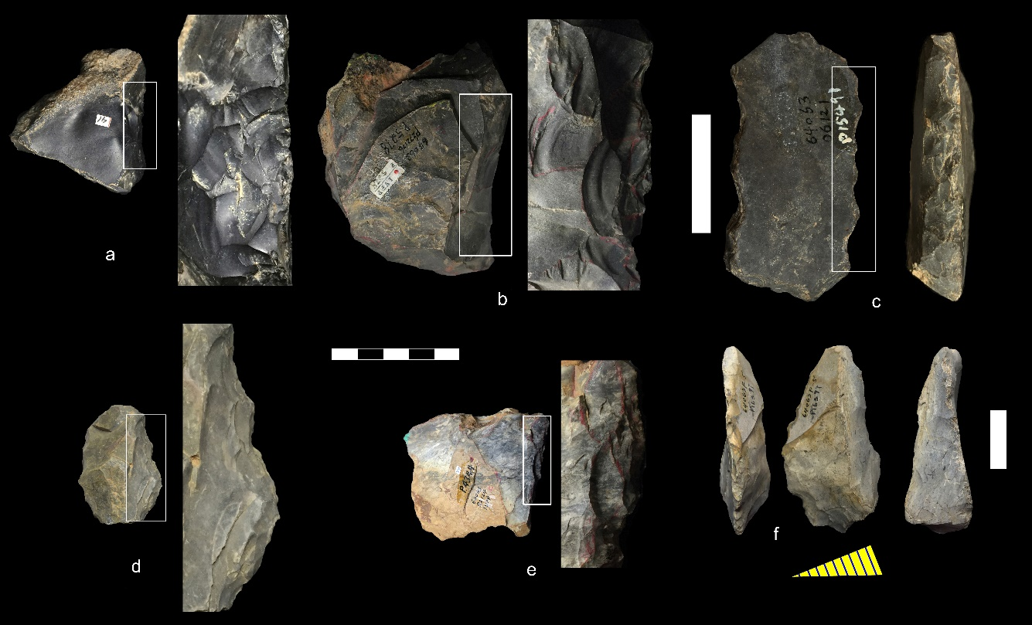

**Figure 3 | Quina tools and retouched blank. (**a-e): Quina scrapers with stepped retouching scars that obtained from several phases of retouching. The white boxes on each tool edge show the areas of which the zoomed details on the right. (f): a blank, once achieved from Quina reduction, was retouched into scraper, the yellow oblique triangle below is the cross-section of the blank.

## Core-on-flake

At Guanyindong, core-on-flake strategies are mainly presented by both truncated-faceted pieces (flakes with a truncation, on one or more margins, that was used as a platform for the removal of one or more small flakes from the exterior surface) and Kombewa knapping (when the ventral surface of a flake was used as a flake-release surface, and the resulting flake may can appear to have two ventral faces) (cf. Dibble and McPherron 2015; Shea 2013). Truncated-facetted pieces have been frequently identified under different names through the Middle to Upper Paleolithic in Africa, Europe, Levant and north Asia (e.g. Dibble 1984, Nishiaki 1985, Debénath 1988, Hovers 2007, Schroeder 2007, Shalagina, Krivoshapkin et al. 2015). It is sometimes regarded as a response to lithic raw material scarcity and to high mobility of forager groups (Wallace and Shea 2006). These pieces usually start from a plain flake which is subsequently knapped along its periphery across the ventral surface. The consequent final morphology is a core with flake scars on the ventral surface, indicating the production of invasive flakes from platforms along the flake’s dorsal edge.

The likely functions of truncated faceted pieces are disputed (Solecki 1970, Dibble 1984, Nishiaki 1985, Goren-Inbar 1988). Some believe they are a type of prepared core (Solecki 1970, Brantingham, Olsen et al. 2000), while others primarily regard them as tools (Shalagina, Krivoshapkin et al. 2015) or "specific oriented products" (Dibble 1984), or thinning for hafting as phrased by Schroeder (2007). In the case of Guanyindong, either working as a core or producing a particular working edge is plausible, subject to the requirement of different scenarios. In order to roughly distinguish from ordinary retouching, however, scars smaller than 10mm on the ventral surfaces are excluded as indictive for this category. Other truncated facets bearing relatively large ventral flake scars and irregular edges suggest they may have been utilized as cores (see examples in **Figure 4a,c and e** and **SI Figure S4**), though we expect the function mutated as needed. The average dimension and mass are 76mm and 135g respectively, which are consistent with the data of general cores in the site (75mm and 175g). The raw material was dominated by chert (80%) and followed by limestone. The exploitation of flakes as blanks for the truncated faceted technique may be evidence of a predetermination concept, since this strategy requires multi-stage production, indicating planning.

Another type of core-on-flake flaking found in Guanyindong is the Kombewa flake. It is evidenced on 21 Kombewa flakes (median maximum dimension = 69mm), and 10 Kombewa cores (median maximum dimension = 82.4mm) most of which show truncated faceting also. Kombewa production (see examples from **Figure 4d,h, f-g**), firstly noted by W.E. Owen (1938, Owen 1939) and further described by Tixier (1980) and Dauvois (1981), is well known in Africa, but has also been found in many lithic industries around Eurasia (see J. Wang 1994, Boëda and Au Présent 2018). During the Early Stone Age, the Kombewa technique (Tixier, Inizan et al. 1980) is mainly used in the Acheulean assemblages from Africa and Europe before the development of Levallois strategies (Inizan 1999). Although this method is known for the production of blanks for core-tools in Africa, it’s also used to produce small flakes (Bordes 1975). At Guanyindong, the Kombewa method is utilized to produce relatively small flakes with sharp edges.

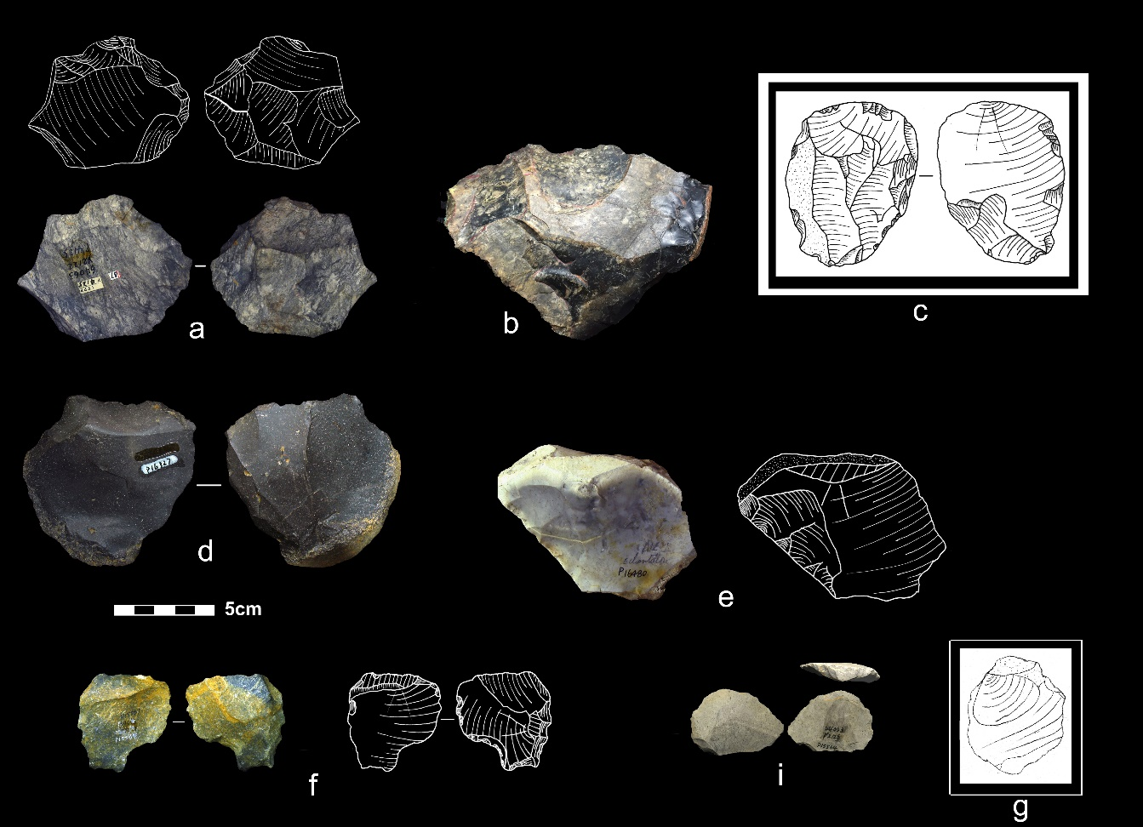

**Figure 4 | Core-on-flakes cores and flakes.** (a-c,e): truncated faceted pieces with flake scars left on the ventral side. (d,g): Kombewa cores with the proximal end being detached. (f,i): Kombewa flakes consist of two ventral surfaces.

## Volumetric exploitation

Cores presenting a volumetric exploitation (e.g. pyramidal, prismatic, etc. geometries, where the striking platform is prepared but the convexities are not prepared and only the natural convexities of the raw block are used) appeared in a small quantity (see examples in **Figure 5 and SI Figure S4**). Those cores are minimally prepared. However, most of them have their striking platform moderately prepared. Those preparations are clearly demonstrated through successive small removals along the striking part, leaving the remainder of the surface nearly untouched (cortical or minimally prepared). The selection of blanks was intentionally focused on columnar nodules or chunks with one flat surface. The flat surface, thus, can potentially serve as a striking platform. The sizes of cores are consistently smaller than general cores (around 50mm), with no cores are found larger than 100mm. Otherwise, the volume is maintained by centralizing the working surface through detachment of rear lateral removals. The core volumes were mainly achieved by semi-rotating debitage removals (Delagnes 1999, Delagnes and Meignen 2006). Direct hard hammer percussion was the technique that reduced cores. Most of cores don’t have any remaining cortex.

However, no products or by-products related to this reduction have been found in the system. This may due to the transportation of end-products outside of the site, or the importation of the cores from elsewhere, since frequent mobility is one of the distinctive strategies of the site.

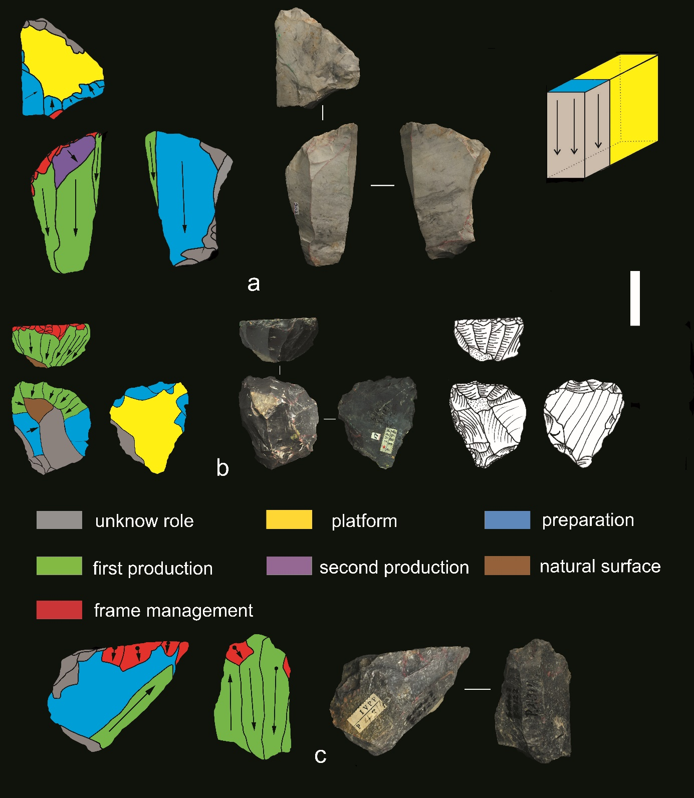

**Figure 5 | Volumetric cores.** (a): scheme and photo of a volumetric core, from which 3 end products are detached. The platform is prepared and the lateral part is removed in order to preparing the flaking surface. (b): scheme, photo and sketch of another volumetric core, from which successive end-products were achieved. Platform and lateral parts are prepared. (c): scheme and photo of another volumetric core. The black arrows with black circle show the directions and impacts of removals. The reduction pattern is bidirectional.

# **Discussion**

The variability of prehistoric knapping was clearly far more complex and multicausal than the classificatory schemes in current use in lithic systematics. This ‘pool of knowledge’ evident at Guanyindong may initially be caused by specific, distinct and isolated groups that implemented techno-cultural diversity repeatedly occupied the cave during the Late Middle Pleistocene (cf. Lycett and Norton 2010). Another potential explanation may be that different technological systems are entangled internally rather than isolated. The flakes produced by a discoid system, for example, can be transferred into a core-on-flake system as evidenced by Faivre (2004). Those by-products or end-products of different strategies can be intertwined inevitably. This kind of lithic production may be considered as a ‘fluid behavioral set’ that is influenced by technique, raw material and environment (Shott, Lindly et al. 2011). This perplexity is broadly documented in many sites, especially in Europe, and described as a ‘fragmented character’ (Turq, Roebroeks et al. 2013). We propose this concept may be relevant to understanding the Guanyindong hominins also. The selection of knapping procedures and manufacture and maintenance of tools of the MP industry at Guanyindong were contingent on numerous factors, including raw materials, on-site activities, mobility, and the environment. All of these factors contributed to the diverse situational circumstances in which stone artefacts were made and used at Guanyindong.

The Guanyindong assemblage is associated with the Marine Isotopic Stages 6 and 5. This means that the MP hominins in Guanyindong cave have experienced at least one significant climate transition from a glacial period (MIS 6) of cooler temperatures to a warmer interglacial condition (MIS 5). These climate fluctuations and vast environmental changes, likely stimulated hominins to alternate among a variety of tool-making strategies as they searched for optimal technological strategies in new and and unfamiliar conditions. During harsher periods, for instance, we infer that people maintained a supply of tools by foraging in larger territories, which resulted in multi-purpose and long-life tools or easily transformed artifacts, such like discoid/Quina production (Delagnes and Rendu 2011, but also see Thiébaut 2013). Another response to these harsher periods are Levallois tools, that are adapted to a variety of hunting strategies in dynamics environments (White and Pettitt 1995).

However, the diversity observed in Guanyindong site is highly fragmented, which cannot be easily interpreted solely on the factors above. The fragments might be attributable to the inherent flexibility and repeatedly high mobility of the MP which is embedded in lithic technologies, as in the case of the Neanderthals assemblages described by Turq, Roebroeks et al. (2013). In the case of Guanyindong, the products of reduction sequences are even more diffuse relative to the western hemisphere. Equal with the mechanism underlying the paucity of the Levallois concept at Guanyindong, the rarity of material traces may have been due to the narrower ranges of technological strategies adopted by fragmented populations, compared to the relative high population and/or high-density conditions of Middle Pleistocene in west Eurasia. Consequently, the weak and/or irregular patterns of social interconnectedness due to small population sizes and densities may have impeded the spread and establishment of technological innovations (Lycett and Norton 2010).

An important limitation to the implications of our analysis of the Guanyindong assemblage is the scarcity of artefact provenance data in the excavation records. Our previous work established that artefacts were produced in two discrete periods, one clustered at around 170 ka (MIS 6) and the other clustered at 80 ka (MIS 5). The large chronological gap (~80-90 ka) between the two periods is due to an erosional hiatus in the deposits. Due to limited resources at the time of initial excavation, the artefacts were not individually labelled with their provenance information. This means that most of the artefacts cannot be confidently allocated to a specific time period. Unfortunately, future excavations at Guanyindong are unlikely to resolve this as most of the excavable deposit was removed by the previous excavators. This also limits our ability to make robust claims about change over time. The diversity described here, for example, on one hand, could either represent coexistence of multiple forms in a certain time. On the other hand, it could represent a sequence of technological changes over time, such as is widely observed at sites in west Eurasia, for example, at Combe Grenal and Pech de l’Aze (Delagnes and Meignen 2006).

In contrast to the fine-grained behavioural evidence and high-resolution technological studies from a wide range of MP sites in West Eurasia, the data from East Asia are sparse and analysis reports are typically coarse-grained. To date, many paleolithic sites in southwest China have been found (Wu 1975, Cao 1978, Qiu 1985, Cai 1991, Zhu 2011, Gao 2012), though only a few of them, such as Guanyindong and Panxiandadong (Huang, Hou et al. 1997, Miller-Antonio, Schepartz et al. 2004, Li, Wu et al. 2017), have been reliably dated to the Late Middle Pleistocene period. Evidence of various traits of MP technologies in Guanyindong, such as Levallois strategies, multiple blank production techniques including discoid and core-on-flake, and various methods on tool manufacture and management such like Quina-like systems, suggests that during MIS 6 – 5 hominins in this area had the comparable response abilities as those in Europe and Africa. In other words, the diversity of lithic production of the assemblage is similar to that found in Late Middle Pleistocene assemblages in west Eurasia and Africa.

Our paper systematically demonstrates the diversity of Middle Palaeolithic in East Asia for the first time, indicating that the appearance of Levallois concept in Guanyindong is not anecdotal and not isolated or simply attributable to random convergence. On the contrary, the Guanyindong hominins developed the many complex elements of Middle Palaeolithic tool-kits, challenging the longstanding view of long-term simplicity in lithic technology during the Early and Middle Palaeolithic periods in East Asia. The absence of human fossils dated to the same period in southwest China, hampers speculation about the hominin species that produced the Guanyindong Cave assemblage. However, accumulated anthropological studies in and/or near this region have shed the light on the probable hominin taxa The Denisovan fossil found in Baishiya, dated 160ka, provides the first evidence of Denisovan territories in East Asia (Chen, Welker et al. 2019). The 100ka old modern human teeth from Fuyan (Liu, Martinon-Torres et al. 2015) ,and shared morphology with the Neandertals found on crania from Xuchang (Li, Wu et al. 2017) suggest that the identity of the hominins that lived here is more complex and interlaced than we previously thought.

The number of available assemblages and current data for the Palaeolithic in the Eastern hemisphere does not at present allow a strong contribution to robustly clarify relationships among technical behaviours and to this debate. A key challenge for future research on other Late Middle Pleistocene sites in this region is to establish more detailed pattern and timing of the Middle Palaeolithic production and whether this is a result of technology convergence or cultural transmission needs further evidence and more studies.

# **Methods**

Based on the technical analyses developed by authors such as Geneste (1988), Boëda et al. (1990, 1993), Geneste et al. (1997) and Vaquero (2008), the whole lithic assemblage was fully studied to record both qualitative and quantitative parameters. The qualitative method follows the general concepts of the chaîne opératoire (Pelegrin, Karlin et al. 1988, Geneste 1991, Sellet 1993, Bar‐Yosef and Van Peer 2009). The process includes the recognition of the raw material, identification of their origins according to previous studies, the reduction strategies of cores such as knapping modes, shaping and retouching according to the observation of technical products, and the retouched or unretouched products (flakes, debris, flake tool types, shaped tools). The quantitative analysis was mainly based on metrical and morphometric data that produces the basic statistics on artifacts dimensions and main attributes of different categories. For the chunks and debris, only mass was measured. The specific description of metrical and morphometric measurements is available in **SI**.

Levallois cores were identified following the guidelines set out by Boëda (1995). The recognition of Levallois products from Levallois system is harder compared with the identification of cores (e.g. Van Peer 1992, Boëda 1995, Shimelmitz and Kuhn 2013). Unfortunately, the recognition of Levallois flakes is not based on refitting analysis due to the insufficiency of specimens. However, several criteria were taken into consider to avoid the arbitrariness. Those criteria include a clearly organized scar pattern (Debénath and Dibble 1993) which indicates the predetermined process, and the angles between the striking platform and debitage surfaces to monitor the percussion angle of the flake, also consideration morphology was included, such as a relatively flat and uniform cross-section (Debénath and Dibble 1993).

In terms of Discoid production, the definition developed by Boëda (1993, 1995) is taken into account here as well as broader criteria (Peresani 1998). The Quina exploitation is identified according to the widely accepted definition of Quina debitage by Bourguignon (1996) and the interpretations of subsequent scholars (e.g. Hiscock, Turq et al. 2009). The core-on-flake consist of two main categories: truncated-faceted and Kombewa debitage. Truncated-faceted has been studied and discussed in a wide range in many reports (e.g. Solecki 1970, Nishiaki 1985, Goren-Inbar 1988, Brantingham, Olsen et al. 2000, Dibble and McPherron 2006, Marwick, Clarkson et al. 2016). Based on the general principles of those reports, we ascribe the truncated-faceted preliminarily to flakes that were truncated first and then removals were detached mostly, but not always, on the ventral surface. The term of Kombewa in the study is referring to a wider meaning rather than Kombewa *stricto sensu* (Tixier and Turq 1999). The recognition of Kombewa method is associated with two bulbs on the proximal end of both the ventral and dorsal surfaces of a flake. Correspondingly, the cores produced these flakes are actually flakes with a pronounced bulb having another flake detached from it, rather than a core nodule (Kombewa flake; Owen 1938, Tixier, Inizan et al. 1980, Dauvois 1981). Our diagnosis of volumetric exploitation used the volumetric concept for reference and analytical approach mentioned by Carmignani (2017).

# **References**

Bae, C. J., K. Douka and M. D. Petraglia (2017). "On the origin of modern humans: Asian perspectives." Science **358**(6368): eaai9067.

Bar-Yosef, O., Kuhn, S.L. (1999). "The big deal about blades: laminar technologies and human evolution." Am. Anthropol **101**: 322-338.

Bar‐Yosef, O. and P. Van Peer (2009). "The Chaîne Opératoire Approach in Middle Paleolithic Archaeology." Current Anthropology **50**(1): 103-131.

Berna, F. and P. Goldberg (2007). Assessing Paleolithic pyrotechnology and associated hominin behavior in Israel.

Binford, L. R. and S. R. Binford (1966 ). "A preliminary analysis of functional variability in the Mousterian of Levallois facies." American Anthropologist

**68**(2): 238-295.

Boëda, E. (1990). De la surface au volume. Analyse des conceptions des d´ebitages Levallois et laminaire. Pal´eolithique moyen r´ecent et Pal´eolithique sup´erieur ancien en Europe (M´emoires du Mus´ee de Pr´ehistoire d’Ile-de-France 3). C. Farizy. Nemours, APRAIF**:** 63–68.

Boëda, E. (1993). "Le débitage discoïde et le débitage Levallois récurrent centripède." Bulletin de la Société préhistorique française **90**: 392-404.

Boëda, E. (1994). Le Concept Levallois: Variabilité des Méthodes.

Boëda, E. (1995). Levallois: A volumetric construction, methods, a technique. The Definition and Interpretation of Levallois Technology. H. Dibble and O. Bar-Yosef. Madison, Prehistory Press**:** 41–68.

Boëda, E. and P. Au Présent (2018). Techno-logique & Technologie Une Paléo-histoire des objets lithiques tranchants.

Boëda, E., J. Connan, D. Dessort, S. Muhesen, N. Mercier, H. Valladas and N. Tisnérat (1996). "Bitumen as a hafting material on Middle Palaeolithic artefacts." Nature **380**(6572): 336-338.

Bordes, F. (1950). "L'évolution buissonnante des industries en Europe occidentale. Considérations théoriques sur le Paléolithique inférieure et moyen." L'Anthropologie **54**: 393-420.

Bordes, F. (1953). "Essai de classiﬁcation des industries “moust´eriennes”." BulletindelaSoci´et´ePr ´ ehistorique Franc¸aise **50**: 457–467.

Bordes, F. (1961). Typologie du Paléolithique Ancien et Moyen. Paris, Centre National de la Recherche Scientifique.

Bordes, F. (1975). "Le gisement du Pech de l'Azé IV. Note préliminaire." Bulletin de la Société préhistorique française. Études et travaux **72**: 293-308.

Bordes, F. (1981). "Vingt-cinqansapr`es:lecomplexemoust´erienrevisit´ e." BulletindelaSoci´et´ePr ´ ehistorique Franc¸aise **78**: 77–87.

Boriskovsky, P. I. (1978). Some problems of the Palaeolithic of South and Southeast Asia. Early Palaeolithic in South and East Asia. F. Ikawa-Smith. The Hague, Mouton**:** 87-97.

Bourguignon, L. (1996). "La conception de debitage quina." Quaternaria Nova **VI**: 149-166.

Brantingham, P. J. and S. L. Kuhn (2001). "Constraints on Levallois Core Technology: A Mathematical Model." Journal of Archaeological Science **28**(7): 747-761.

Brantingham, P. J., J. W. Olsen, J. A. Rech and A. I. Krivoshapkin (2000). "Raw Material Quality and Prepared Core Technologies in Northeast Asia." Journal of Archaeological Science **27**(3): 255-271.

Breuil, H. and L. Koslowski (1932). "E ´tudes de stratigraphie pale´olithique dans le norddelaFrance,laBelgique,etl’Angleterre." L’Anthropologie **42**: 27–47.

Cârciumaru, M., R.-M. Ion, E.-C. Niţu and R. Ştefănescu (2012). "New evidence of adhesive as hafting material on Middle and Upper Palaeolithic artefacts from Gura Cheii-Râşnov Cave (Romania)." Journal of Archaeological Science **39**(7): 1942-1950.

Cai, H. W., Xinjin.; Xu, Chunhua (1991). "Paleolith of Bianbian cave at Bijie county, Guizhou province." Acta Anthropologica Sinica **10**(1): 50-57.

Cao, Z. (1978). "Palaeolithic site found in Xiaohuidong cave at Shuicheng, Guizhou Province." Vertebrata Palasiatica **16**(1): 67-72.

Carmignani, L., M.-H. Moncel, P. Fernandes and L. Wilson (2017). "Technological variability during the Early Middle Palaeolithic in Western Europe. Reduction systems and predetermined products at the Bau de l'Aubesier and Payre (South-East France)." PLOS ONE **12**(6): e0178550.

Chen, F., F. Welker, C.-C. Shen, S. E. Bailey, I. Bergmann, S. Davis, H. Xia, H. Wang, R. Fischer, S. E. Freidline, T.-L. Yu, M. M. Skinner, S. Stelzer, G. Dong, Q. Fu, G. Dong, J. Wang, D. Zhang and J.-J. Hublin (2019). "A late Middle Pleistocene Denisovan mandible from the Tibetan Plateau." Nature **569**(7756): 409-412.

Commont, V. (1908). "Les industries de l’ancien Saint-Acheul." L’Anthropologie **19**: 527–572.

D'Errico, F. (2008). "Le rouge et le noir: implications of early pigment use in Africa, the near East and Europe for the origin of cultural modernity." Goodwin Series **10**: 168-174.

Dauvois, M. (1981). De la simultanéité des concepts Kombewa et Levallois dans l’Acheuléen du Maghreb et du Sahara nord-occidental. Préhistoire Africaine. H. H. J. Roubet C., Souville G. Paris**:** 313-321.

Debénath, A. (1988). Recent thoughts on the Riss and Early Wurm lithic assemblages of la Chaise de Vouthon (Charente, France). Upper Pleistocene Prehistory of Western Eurasia. H. L. Dibble and A. Montet-White. Philadelphia, University of Pennsylvania.

Debénath, A. and H. L. Dibble (1993). Handbook of Paleolithic Typology: Lower and Middle Paleolithic of Europe. Philadelphia, University of Pennsylvania Press.

Delagnes, A. (1999). Blade Production During the Middle Paleolithic in Northwestern Europe. Blade Production During the Middle Paleolithic in Northwestern Europe, China, Acta Anthropologica Sinica (Supplement to Vol. 19).

Delagnes, A. and L. Meignen (2006). Diversity of lithic production systems during the Middle Paleolithic in France : are there any chronological trends?**:** 85-108.

Delagnes, A. and W. Rendu (2011). "Shifts in Neandertal mobility, technology and subsistence strategies in western France." Journal of Archaeological Science **38**(8): 1771-1783.

Delpiano, D. and M. Peresani (2017). "Exploring Neanderthal skills and lithic economy. The implication of a refitted Discoid reduction sequence reconstructed using 3D virtual analysis." Comptes Rendus Palevol **16**(8): 865-877.

Dibble, H. (1984). "The Mousterian Industry from Bisitun Cave (Iran)." Paleorient **10**(23-34).

Dibble, H., L. and S. McPherron, P. (2006). "The missing Mousterian." Current Anthropology **47**(5): 777.

Dibble, H. L. (1984). "Interpreting typological variation of Middle Paleolithic scrapers: function, style, or sequence of reduction? Journal of Field Archaeology." Journal of Field Archaeology **11**(431-436).

Dibble, H. L. (1987). "The Interpretation of Middle Paleolithic Scraper Morphology." American Antiquity **52**(1): 109-117.

Eric Boëda, J.-M. G., Liliane Meignen (1990). "Identification de chaînes opératoires lithiques du Paléolithique ancien et moyen." Paléo **2**: 43-80.

Faivre, J. P. (2004). "L’industrie lithique moustérienne du niveau G7 des Fieux (Miers, Lot): des matériaux, des schémas opératoires, un même objectif." Paléo **16**: 71-90.

Foley, R. and M. M. Lahr (2003). "On stony ground: Lithic technology, human evolution, and the emergence of culture." Evolutionary Anthropology: Issues, News, and Reviews **12**(3): 109-122.

Fontana, F., M. H. Moncel, G. Nenzioni, G. Onorevoli, C. Peretto and J. Combier (2013). "Widespread diffusion of technical innovations around 300,000 years ago in Europe as a reflection of anthropological and social transformations? New comparative data from the western Mediterranean sites of Orgnac (France) and Cave dall’Olio (Italy)." Journal of Anthropological Archaeology **32**(4): 478-498.

Gamble, C. (1999). Palaeolithic societies of Europe. Cambridge, Cambridge University Press.

Gao, F., Min, R., Li, B., Duan, C. (2012). The significance of the first archaeological excavation of Yushuiping sites in Nujiang The Nu Nationality in the Canyon. Y. Zhang, Li, S. Yunnan Province, China, Yunnan univeristy press.

Gao, X. (1999). "A discussion of the 'Chinese Middle Paleolithic'." Acta Anthropologica Sinica **18**(1): 1-16.

Gao, X. and C. J. Norton (2002). "A critique of the Chinese 'Middle Palaeolithic'." Antiquity **76**(292): 397-412.

Geneste, J.-M. (1988). Systèmes d’approvisionnement en matières premières au Paléolithique moyen et au Paléolithique supérieur en Aquitaine. L’Homme de Néandertal. M. Otte. La Mutation. **8:** 61-70.

Geneste, J.-M. (1991). "Systèmes techniques de production lithique: variations techno-e ´conomiques dans les processus de re ´alisation des outillages pale ´olithiques." Techniques et culture **17-18**: 1-35.

Geneste, J.-M., J. Jaubert, M. Lenoir, L. Meignen and A. Turq (1997). "Approche technologique des Moustériens charentiens du sud-ouest de la France et du Languedoc oriental." Paleo **9**: 101-142.

Goldberg, P., H. Dibble, F. Berna, D. Sandgathe, S. McPherron and A. Turq (2012). New evidence on Neandertal use of fire: Examples from Roc de Marsal and Pech de l'Azé IV.

Goren-Inbar, N. (1988). Too Small to Be True? Reevaluation of Cores on Flakes in Levantine Mousterian Assemblages.

Goren-Inbar, N. (2011). Behavioral and Cultural Origins of Neanderthals: A Levantine Perspective. Continuity and Discontinuity in the Peopling of Europe: One Hundred Fifty Years of Neanderthal Study. S. Condemi and G.-C. Weniger. Dordrecht, Springer Netherlands**:** 89-100.

Hardy, B. L. (2004). "Neanderthal behaviour and stone tool function at the Middle Palaeolithic site of La Quina, France." Antiquity **78**(301): 547-565.

Hiscock, P., A. Turq, J. P. Faivre and L. Bourguignon (2009). Quina Procurement and Tool Production. Lithic Materials and Paleolithic Societies. B. Adams and B. S. Blades**:** 232-246.

Hovers, E. (2007). The many faces of cores-on-flakes: a perspective from the Levantine Mousterian. Cores or Tools? Alternative Approaches to Stone Tool Analysis. S. P. McPherron. Cambridge, Cambridge Scholars Press**:** 42-74.

Hu, Y., B. Marwick, J.-F. Zhang, X. Rui, Y.-M. Hou, J.-P. Yue, W.-R. Chen, W.-W. Huang and B. Li (2019). "Late Middle Pleistocene Levallois stone-tool technology in southwest China." Nature **565**(7737): 82-85.

Huang, W., Y. Hou and X. Si (1997). "Stone industry from Panxian Dadong, a cave-site of southeastern China." Acta Anthropologica Sinica **16**(3): 171-192.

Hublin, J.-J., A. Ben-Ncer, S. E. Bailey, S. E. Freidline, S. Neubauer, M. M. Skinner, I. Bergmann, A. Le Cabec, S. Benazzi, K. Harvati and P. Gunz (2017). "New fossils from Jebel Irhoud, Morocco and the pan-African origin of Homo sapiens." Nature **546**(7657): 289-292.

Hublin, J. J. (2009). "The origin of Neandertals." Proceedings of the National Academy of Sciences **106**(38): 16022.

Inizan, M.-L., Reduron-Ballinger, M., Roche, H., Tixier, J., (1999). Technology and Terminology of Knapped Stone. Paris, CREP, Nanterre.

J. Wang, F. H. T., Y.R. Wang (1994). "The report of excavation and survey at the Dingcun Site." Journal of Chinese Antiquity(3): 1-75.

Jacobs, Z., B. Li, M. V. Shunkov, M. B. Kozlikin, N. S. Bolikhovskaya, A. K. Agadjanian, V. A. Uliyanov, S. K. Vasiliev, K. O’Gorman, A. P. Derevianko and R. G. Roberts (2019). "Timing of archaic hominin occupation of Denisova Cave in southern Siberia." Nature **565**(7741): 594-599.

Jaubert, J. (1993). Le gisement paléolithique moyen de Mauran (Haute-Garonne): Techno-économie des industries lithiques.

Kei, Y. M. (2012). "The Middle Palaeolithic in China a review of current interpretations." Antiquity **86**(333): 619-626.

Kuhn, S. L. (2013). "Roots of the Middle Paleolithic in Eurasia." Current Anthropology **54**(SUPPL8.): S255-S268.

Lenoir, M. (1986). " Un mode d'obtention de la retouche Quina dans le Mousterien de Combe Grenal (Domme, Dordogne)." Bulletin de la Soci´et´e d’Anthropologie du Sud-Ouest XXI: 153-160.

Leroi-Gourhan, A. (1964). Le Geste et la Parole. I, Technique et langage. Sciences d’Aujourd’hui. A. Michel. Paris.

Leroi-Gourhan, A. (1966). La Prehistorie. Paris, University of France Press.

Li, Y., Wen, B. (1986). "Guanyindong: A Lower Paleolithic Site at Qianxi County, Guizhou Province." 1–181.

Li, Z.-Y., X.-J. Wu, L.-P. Zhou, W. Liu, X. Gao, X.-M. Nian and E. Trinkaus (2017). "Late Pleistocene archaic human crania from Xuchang, China." Science **355**(6328): 969.

Liu, W., M. Martinon-Torres, Y.-j. Cai, S. Xing, H.-w. Tong, S.-w. Pei, M. J. Sier, X.-h. Wu, R. L. Edwards, H. Cheng, Y.-y. Li, X.-x. Yang, J. M. B. de Castro and X.-j. Wu (2015). "The earliest unequivocally modern humans in southern China." Nature **526**(7575): 696-699.

Lycett, S. J. and M. I. Eren (2013). "Levallois economics: an examination of 'waste' production in experimentally produced Levallois reduction sequences." Journal of Archaeological Science **40**(5): 2384-2392.

Lycett, S. J. and C. J. Norton (2010). "A demographic model for Palaeolithic technological evolution: The case of East Asia and the Movius Line." Quaternary International **211**(1–2): 55-65.

Marwick, B., C. Clarkson, S. O'Connor and S. Collins (2016). "Early modern human lithic technology from Jerimalai, East Timor." Journal of Human Evolution **101**: 45-64.

McBrearty, S. and A. S. Brooks (2000). "The revolution that wasn't: a new interpretation of the origin of modern human behavior." Journal of Human Evolution **39**(5): 453-563.

Miller-Antonio, S., L. A. Schepartz, P. Karkanas, H. Yamei and et al. (2004). "Lithic Raw Material Use at the Late Middle Pleistocene Site of Panxian Dadong." Asian Perspectives **43**(Fall): 314.

Monnier, G. (2006). "The Lower/Middle Paleolithic Periodization in Western Europe An Evaluation." Current Anthropology **47**(5): 709-744.

Mortillet, G. d. (1873). Classiﬁcation des diverses pe´riodes de l’A ˆge de la Pierre. Congre`s International d’Anthropologie et d’Arche´ologie Pre´historiques, 6e`me session**:** 432–459.

Movius, H. L. (1948). "The Lower Palaeolithic cultures of southern and eastern Asia." Transactions of the American Philosophical Society **38**(4): 329-420.

Nishiaki, Y. (1985). Truncated-facetted flakes from Levantine Mousterian assemblage. Bulletin of the Department of Archaeology (The University of Tokyo). Tokyo, The Univ. of Tokyo**:** 215-226.

Norton Christopher, J. and J. H. Jin Jennie (2009). "The evolution of modern human behavior in East Asia: Current perspectives." Evolutionary Anthropology: Issues, News, and Reviews **18**(6): 247-260.

Owen, W. E. (1938). The Kombewa Culture, Kenya Colony. Man, Royal Anthropological Institute of Great Britain and Ireland. **38:** 203-205.

Owen, W. E. (1939). "AN AMATEUR FIELD COLLECTOR IN KAVIRONDO." African Affairs **XXXVIII**(CL): 124-132.

Pasty, J.-F. (2000). "Le gisement Paléolithique moyen de Meillers (Allier) : un exemple de la variabilité du débitage Discoïde." Bulletin de la Société préhistorique française **97**(2): 165-190.

Pelegrin, J., C. Karlin and P. Bodu (1988). Chaines Opératoires: un outil pour le Préhistorien. Journee d 'Etudes Technologiques en Prehistoire. J. Tixier. Paris, CNRS**:** 55-62.

Peresani, M. (1998). "La variabilité du débitage discoïde dans la grotte de Fumane (Italie du Nord)/The variability of discoid production at the grotte de Fumane " Paléo **10**: 123-146.

Peresani, M., Ed. (2003). Discoid lithic technology : advances and implications. Oxford :, Archaeopress,.

Preysler, J. (2010). Experimental Approach to the Function and Technology of Quina Side-Scrapers**:** 172-202.

Qiu, Z., Zhang, Y. (1985). "Human tooth and Paleoliths found at locality 2 of Longtanshan, Chenggong, Kunming." Acta Anthropologica Sinica **4**(3): 233-241.

Rolland, N. and H. L. Dibble (1990). "A New Synthesis of Middle Paleolithic Variability." American Antiquity **55**(3): 480-499.

Rots, V. (2009). The functional analysis of the Mousterian and Micoquian assemblages of Sesselfelsgrotte, Germany. Tool use and Hafting in the European Late Middle Paleolithic.

Schroeder, B. (2007). "Truncated-faceted pieces from Jerf Al-Ajla." Tools Versus Cores. Alternative Approaces to Stone Tool Analysis: 17-41.

Sellet, F. (1993). "Chaine Operatoire; The Concept and Its Applications." Lithic Technology **18**(1-2): 106-112.

Shalagina, A. V., A. I. Krivoshapkin and K. A. Kolobova (2015). "TRUNCATED-FACETED PIECES IN THE PALEOLITHIC OF NORTHERN ASIA." Archaeology, Ethnology and Anthropology of Eurasia **43**(4): 33-45.

Shennan, S. (2001). "Demography and Cultural Innovation: a Model and its Implications for the Emergence of Modern Human Culture." Cambridge Archaeological Journal **11**(01): 5-16.

Shimelmitz, R. and S. Kuhn (2013). "Early Mousterian Levallois technology in Unit IX of Tabun Cave." Paleoanthropology **2013**: 1-27.

Shimelmitz, R., M. Weinstein-Evron, A. Ronen and S. L. Kuhn (2016). "The Lower to Middle Paleolithic transition and the diversification of Levallois technology in the Southern Levant: Evidence from Tabun Cave, Israel." Quaternary International **409**: 23-40.

Shott, M. J., J. Lindly and G. A. Clark (2011). "Special issue: reduction sequence, chaîne opératoire, and other methods: the epistemologies of different approaches to lithic analysis. Continuous modeling of core reduction: lessons from refitting cores from WHS 623x, an Upper Paleolithic site in Jordan." PaleoAnthropology **11**: 320-330.

Solecki, R. L. S., R. S. (1970). "A new secondary flaking technique at the Nahr Ibrahim cave site, Lebanon." Bulletin Du Musee De Beyrouth **23**: 137-142.

Soressi, M. and F. d'Errico (2007). Pigments, gravures, parures: les comportements symboliques controversés de Néandertaliens.

Thiébaut, C. (2013). "Discoid debitage stricto sensus: a method adapted to highly mobile Middle Paleolithic groups?" Palethnologie: 4-20.

Tixier, J. (1978). Méthode pour l'étude des outillages lithiques. Thèse d'Etat Thèse d'Etat, Université de Paris X-Nanterre.

Tixier, J., M. L. Inizan and H. Roche (1980). Préhistoire de la pierre taillé 1: terminologie e technologie. Valbone, Centre de Recherches et d'études Pré-historiques.

Tixier, J. and A. Turq (1999). "Kombewa et alii." Paléo **11**: 135-143.

Tryon, C. A., S. McBrearty and P.-J. Texier (2005). "Levallois Lithic Technology from the Kapthurin Formation, Kenya: Acheulian Origin and Middle Stone Age Diversity." African Archaeological Review **22**(4): 199-229.

Turq, A., W. Roebroeks, L. Bourguignon and J.-P. Faivre (2013). "The fragmented character of Middle Palaeolithic stone tool technology." Journal of Human Evolution **65**(5): 641-655.

Van Peer, P. (1992). The Levallois Reduction Strategy. Madison, Prehistory Press.

Vaquero, M. (2008). "The history of stones: behavioural inferences and temporal resolution of an archaeological assemblage from the Middle Palaeolithic." Journal of Archaeological Science **35**(12): 3178-3185.

Wallace, I. J. and J. J. Shea (2006). "Mobility patterns and core technologies in the Middle Paleolithic of the Levant." Journal of Archaeological Science **33**(9): 1293-1309.

Wang, Y. (2017). "Late Pleistocene Human Migrations in China." Current Anthropology **58**(S17): S504-S513.

White, M. J. and P. B. Pettitt (1995). "Technology of early Palaeolithic western Europe: innovation, variability and a unified framework." Lithics **16**: 27-40.

Wu, M. W. L. Z., Yinyun; Zhang, Senshui (1975). "Ancient Human fossils and cultural remains in Tongzi, Guizhou Province." Vertebrata Palasiatica **13**(1): 14-23.

Zhu, Z. J., Xueping (2011). "Study on the Stone Artifacts From the Laohu Cave Paleolithic Site , Baoshan County, Yunnan " Research of China's frontier archaeology **4**.

# **Acknowledgments**

This work was supported by the Australian Research Council through Future Fellowships to B.L. (FT140100384) and B.M. (FT140100101). Postgraduate scholarships from the University of Wollongong to Y.H., the Chinese Academy of Science (CAS) Strategic Priority Research Program Grants of “Macroevolutionary Processes and Paleoenvironments of Major Historical Biota” (No. XDPB05), State Key Laboratory of Loess and Quaternary Geology, Institute of Earth Environment, CAS (No. SKLLQG1501) and National Science Foundation of China (No. 41272033) to Y.-M.H.

# **Author contributions**

B.L., Y.H. and W.-W.H. conceived and coordinated the study. Y.H., B.L. and Y.-M.H. conducted the fieldwork. Y.H., B.M. and Y.-M.H. conducted the stone artefact analysis. Y.H. and B.M. wrote the manuscript, with contributions from the other authors.